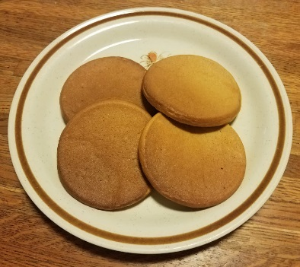
Pumpkin Whole Wheat Pancakes
Ingredients
- 4 cups white whole wheat flour
- 4 tablespoons raw unfiltered honey
- 2 tablespoons baking powder
- 1 teaspoon salt
- 1 teaspoon baking soda
- 3½ cups milk
- ¼ cup avocado oil
- ½ cup applesauce
- 4 large eggs
- 1 15 oz. can pumpkin
Instructions
- Place all ingredients in a large mixing bowl and blend until smooth.
- Let batter sit for 5 minutes before using.
- Preheat 11” square frying pan on medium heat.
- Pour 1/3 cup batter for each pancake into the pan (4 per pan).
- Cook for 3-4 minutes.
- Flip the pancakes and cook for 3-4 more minutes.
- Remove onto a plate or cooling rack.
- Repeat with remaining batter.
- Enjoy!
These may be frozen and then reheated in a toaster.

